**NORTHERN YOUTH FOOTBALL & CHEER**

**Board Meeting Minutes of JUNE 2024**

Location: Meeting conducted Virtually

***ATTENDANCE:***

**Members in attendance:**

Ed Whitt, Ross Fronk, Amanda Divittore, Brittany Hess, Danielle Peters, Leah Simoncini, Matt Sadler, Nichol Hare, Cody Lighty, Kathy Walker, Tim Barrouk

**Members not present:**

**Attendance by non-members/public:**

***WHEREAS*** the NYFC Board Meeting was not held in person. Notes were sent virtually to the secretary, Brittany Hess to compile minutes for June.

**REGISTRATION NUMBERS AS OF 6/21/24**

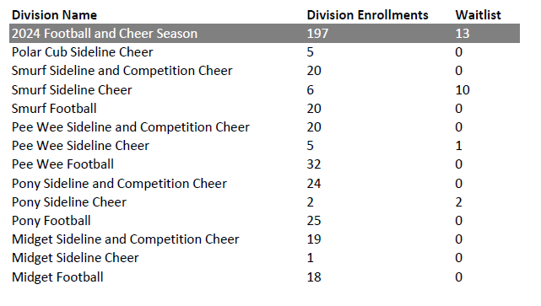

**Danielle Peters- Cheer Report**

UNIFORMS

* Uniform fittings are June 18, 20 and 24
* Uniform Handouts will be the first week of practices.
* Bows have been purchased, and will be handed out with uniforms.

CHEER CAMP

* 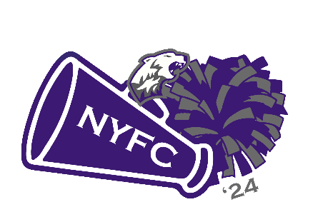To be held July 20, location SLC Gym.
* Currently 43 cheerleaders RSVP’d.
  + Charging $50 per cheerleader
    - Includes t-shirt
      * Cost of shirts is $10.75/each
      * Design for shirt:
* Pizza lunch provided
  + Will need drinks, plates, napkins and chips.

TUMBLING CLASSES AT FLIPPING OUT TUMBLING & NEXT LEVEL SPORTS

* Began June 2

COACHES

|  |  |  |
| --- | --- | --- |
| **Squad** | **Position** | **Applicant's 1st Choice** |
| **Polar Cub** | Head Coach | Leah Simoncini |
|  | Assistant Coach | Alaina O’Brien |
| **Smurf** | Head Coach | Chelssee Smith |
|  | Co-Coaches | Sophia Lobo, Aubrey Gilbert, and Nina Leister |
| **PeeWee** | Head Coach | Kendal Beck and Kira Bidelspacher |
|  | Assistant Coach | Shannon Buhrman, Kiarra Lighty |
| **Pony** | Head Coach | Jasmine Kessler |
|  | Assistant Coach | Tara Edwards, Haylee Alleman, and Sierra Plattenburg |
| **Midget** | Head Coach | Kendra (Nichols) Cooper |
|  | Assistant Coach | Jen Beck and Avery Cooper |

* Coaches meeting to be held July 2 @ 6:15 p.m. at Logan Park

**Ed Whitt – Notes**

* CFA: Tentative Virtual Registration meeting 24 June at 7:00PM. Brittany is on standby.
* Next CFA meeting: 8 July,  7:PM at Shaffer Field (East Penn) football/baseball field house. I need either Ross or Tim to attend if possible,  if them 2 can't do it someone on board will have to step up as I am out of town.
* Registration Rosters emailed Friday, 16 August
* Registration Book meeting (in person meeting) is 18 August 2024.
* Field line, still looking for company.  I reached out to Dillsburg Line Company and they do not do Fields. Ben will reach out to his contact, last resort we will use our hand held line machine.
* Coordinated with new game manager (Jason Stacknick). Outlined that he is responsible for running clock, score board,  and calling games. He agreed to do this as the majority of his duties, to include anything that Northern AD needs him to do.
* Volunteer payment waiver discussion,  it was brought to my attention, that there wasn't an official vote on waiving fee for Head Coach, 2 assist coaches,  and executive board members. I personally believe that this is fair based on those coaches and executive board members hours invested in NYFC. Additionally this comes at a time where Cheerleader participation has exploded, we no longer have to man the Scoreboard box, and have done a really good job at fund raising.  Either way,  point of discussion needs to be had to include official vote.
* Funding assistance request,  we had I community member request assistance for fee. Since the Rider William foundation is suspended, one of our community members agreed to cover fee and Tim Barrouk will coordinate payment.  Ed identified cleat size and will purchase cleats.
* Remove Rider William Foundation from the NYFC website.
* Football equipment had out moved from July 1 and 2, to 22 and 23 July.
* Ed to validate scale, the 2023 Weigh Master volunteered to do the 2024 season.
* NYFC will reopen Football registration until 10 August 2024. Allowing for max registration prior to 6 August roster submission requirement. The NYFC will continue to allow participants up until 4 weeks into the season.
* Anti Bullying Policy was prepped and completed by Danielle Peters.

**Nicole Hare – Fundraising Notes**

* Fundraising - working on finalizing fundraiser calendar
* Volunteer - still waiting for Cody to send me items for time to sign up sheets need those asap so I can get them ready for board approval and to go live Aug 1st.
* Danielle asked that we write up something to go over volunteer spots so new parents know what they are signing up for I will work on this next week to go with the volunteer letter and send a copy to the board for approval.

**Amanda Divitorre – Treasurer Report**

* Riddell has been paid for helmets/pads - $7,618.74
* Taxes for 2023 year have been filed and paid for with Dillsburg Accounting & Tax - $676.88
* Portable toilets have been ordered and will be delivered on 7/26/2024. Squares will need to be marked on grass as to where they are to be placed. Bigger one near the school and smaller one near the shed.
* Registration as of 6/18 is $21, 281.94, this includes cheerleading camp.
* $2 raffle tickets were purchased and given to cheerleaders that came to uniform fitting. Cost to make 5,000 was $260, which was paid by Danielle and she was reimbursed.
* Balance as of today 6/21 is $42, 634.00

Next meeting will be held on Tuesday JULY 16TH at 6:30pm at the Dillsburg VFW